Englannin sanakoe

Huonekalut Nimi:___________________________________________

- Sänky ________________________________________________________________

- Pöytä _________________________________________________________________

- Matto _________________________________________________________________

- Sohva _________________________________________________________________

- Tuoli __________________________________________________________________

- Tyyny _________________________________________________________________

- Verho __________________________________________________________________

- Työpöytä ______________________________________________________________

- Lamppu _______________________________________________________________

- Kirjahylly _____________________________________________________________ ________ / 10

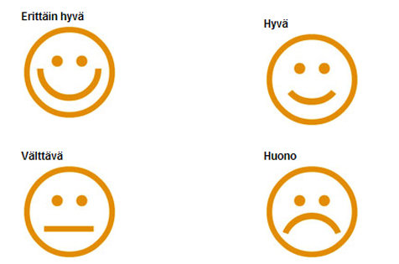
Miten osasin?

